DEPARTMENT OF ECONOMICS JESUS AND MARY COLLEGE OVERVIEW 2023-24

**CHANAKYA IN COLLABORATION WITH T.I.M.E INSTITUTE**

* Date: September 09, 2023
* Time: 11 am onwards
* Platform: Zoom
* Attendees: 42

Chanakya, The Economics Cell of JMC, in partnership with T.I.M.E Institute, organized an online MBA session titled "CAT- Crack in 3 Months" on September 9, 2023, via Zoom.

Moderated by Sneha Gupta, the session featured Mr. Amit Poddar, a seasoned education professional, who delivered a comprehensive presentation on pursuing an MBA, excelling in aptitude tests, and insights into CAT 2022 patterns and cutoffs. The event included interactive problem-solving and a stimulating Q&A session, offering valuable guidance to university students on their MBA journey and career prospects.

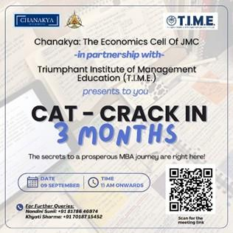

**CHANAKYA IN COLLABORATION WITH SUNPEDAL RIDE**

* Date: September 29, 2023
* Time: 12:30-2:00 pm
* Venue: AV ROOM
* Attendees: 62

On September 29, 2023, Chanakya, the Economic Cell of Jesus and Mary College, in collaboration with SunPedal Ride, hosted a significant event focused on electric mobility and sustainability. Moderated by Aarushi Singh, the session featured Mr. Sushil Reddy, founder of SunPedal Ride, as the guest speaker. Mr. Reddy enlightened attendees on electric

mobility's benefits, distinguishing features from conventional vehicles, and opportunities for skill development in the sector. The event sparked engaging discussions, with participants posing questions on electric vehicle safety and feasibility.

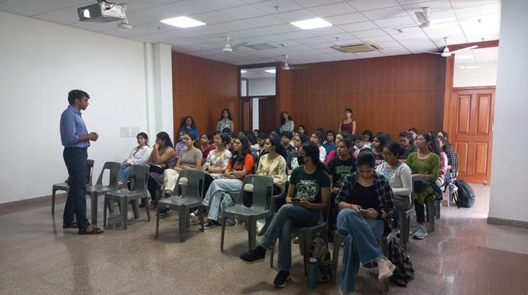

A knowledge quiz further tested attendees' understanding of sustainable development. The session concluded with a token of appreciation presented to Mr. Reddy and an opportunity for attendees to explore his electric vehicle, marking a successful effort in promoting awareness and understanding of sustainable energy and electric mobility.

# Report on Ecovantage 2023-24

The Economics Department hosted its annual fest, Ecovantage, on the 31st of October, 2023. This much-anticipated event brought together students, faculty, and esteemed guests to engage in a series of intellectually stimulating competitions and discussions.

The day commenced at 10 am with an inaugural talk by the chief guest, Rahul Chhabbar, an ambassador of the Indian Foreign Service. He delivered an enlightening speech on India's G20 presidency, shedding light on the country's role and strategic initiatives in the global economic landscape. His insights set the tone for the day, inspiring attendees with a deep understanding of international economics and diplomacy.

Following the inaugural talk, the fest featured "Stock Talk," a competition designed to test students' abilities in maintaining their stocks and portfolios. Participants were challenged to achieve the highest returns, demonstrating their financial acumen and strategic investment

skills. This event provided a practical platform for budding economists to apply theoretical knowledge in a simulated market environment.

The fest also included "Protagoras," a debate competition that encouraged participants to engage in rigorous discourse on various economic issues. Debaters showcased their oratory skills and critical thinking abilities, contributing to a lively and thought-provoking atmosphere.

Another engaging event was "Puzzle Pint," where participants tackled puzzles related to economic theories and concepts. This competition tested their analytical skills and ability to think outside the box, fostering a spirit of problem-solving and innovation.

"Strat Wars" was a highlight of the fest, focusing on game theory and strategic thinking. Participants learned about the fundamental concepts of game theory and its practical applications through interactive sessions and competitive games. This event was particularly beneficial in helping students understand the strategic decision-making processes in economics.

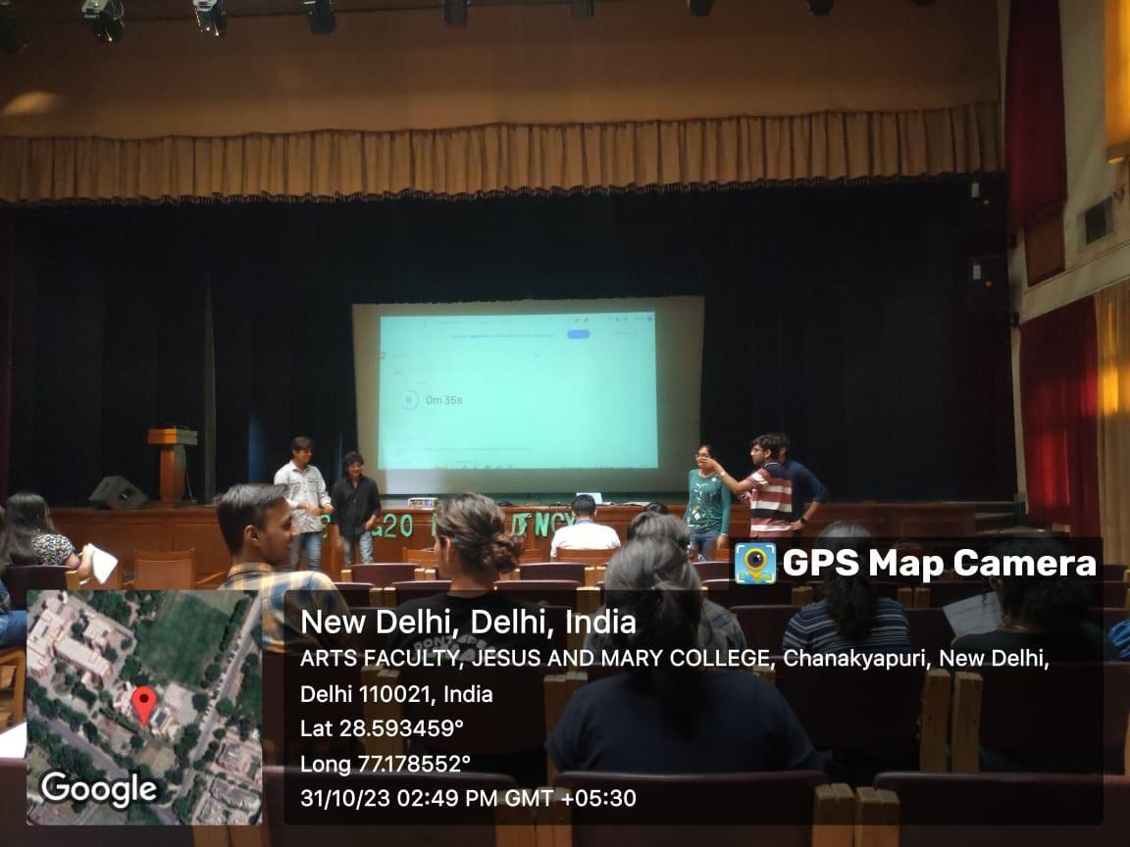

The "Xavion" case study competition required participants to analyze and present solutions to real-world economic scenarios. This event honed their research and presentation skills, as they were tasked with developing comprehensive strategies to address complex economic challenges.

Lastly, the "Research Symposium" was a platform for students to showcase their research capabilities. Participants were given a stipulated time to write research papers on various economic topics, demonstrating their ability to conduct thorough research and articulate their findings effectively.

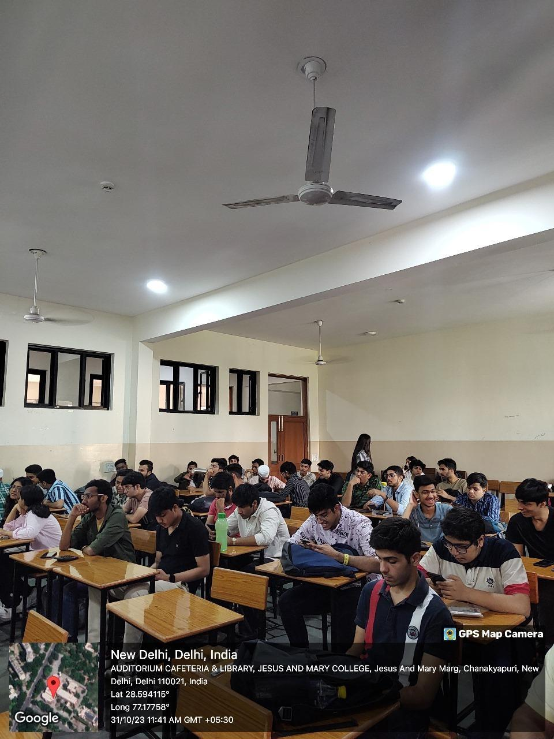

Ecovantage 2023-24 was a resounding success, offering a rich blend of academic rigor and practical application. It provided a valuable opportunity for students to enhance their knowledge, develop critical skills, and engage with experts in the field of economics. The event truly embodied the spirit of intellectual curiosity and academic excellence that the Economics Department strives to cultivate.

# **Contrarian: Speaker session on Black Economy**

* Date: November 2, 2023
* Time: 12.30 p.m.
* Venue: Room 308
* Attendees: 25+

The Contrarian, magazine of Jesus and Mary College's Department of Economics, hosted a speaker session on the 'Black Economy' featuring alumna Ms. Dhwani Nagpal from the World Economic Forum. Ms. Nagpal highlighted the pervasive impact of illicit economy globally and its accelerators like technology and globalization, along with threat multipliers such as climate change and inequality. The session, enriched by Ms. Nagpal's insights and interactive style, concluded on an inspiring note with a vote of thanks from Hima Mary Jacob, Deputy Editor-in-Chief.

# Chanakya session: Career after graduation India and Abroad in collaboration with T.I.M.E. Institute

* Date – 21st February 2024
* Time - 1:00-2:00pm
* Venue – L2
* Total Attendees: 45

On February 21, 2024, the Economics Cell of Jesus and Mary College hosted an informative session in L-2, featuring T.I.M.E institute, focused on post-graduation career paths in India and abroad. The session, from 1:00 to 2:00 pm, saw active participation from attendees including Ms. Megha Jacob, Ms. Shyma Jose, and Ms. Subasini Maharana.

Sneha Gupta, the treasurer, welcomed participants, setting the stage for discussions led by speakers Mr. Prashant Srivastav and Mr. Girish, facilitated by Ms. Megha and Ms. Shyama. Key topics included differentiating between careers and jobs, aligning personal aspirations with professional goals, and the evolving job landscape's emphasis on practical skills and continuous learning.

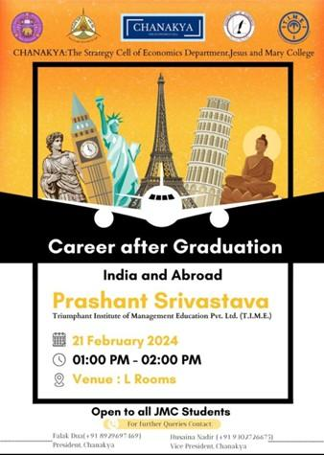

The seminar highlighted the role of academic backgrounds in career development, stressing the importance of internships and extracurricular activities for skill enhancement. It also provided guidance on RBI exams, MBA preparations, and entrance procedures. Husaina Naider concluded the session with gratitude to speakers, teachers, the core team, and participants for their contributions, leaving attendees equipped with valuable insights for their professional journeys.

# Chanakya session

* Date: 28th February, 2024
* Time: 1:15pm - 2:10pm
* Venue: Room 208
* Total Attendees: 30

Chanakya, The Economics Cell at Jesus and Mary College, hosted an insightful session titled "Writing Articles without Using AI" in room 208. The session, led by Dr. Shyma Jose, emphasized ethical writing practices and the limitations of AI-generated content. Dr. Shyma guided the 30 attendees through steps such as critical thinking, thorough research using sources like JSTOR, and the importance of personal input to ensure originality. She highlighted audience consideration, data availability checks, proper citations, and tailored article structures based on the type of writing. The session concluded with a Q&A, enriching participants with essential skills for writing creatively and thoughtfully.

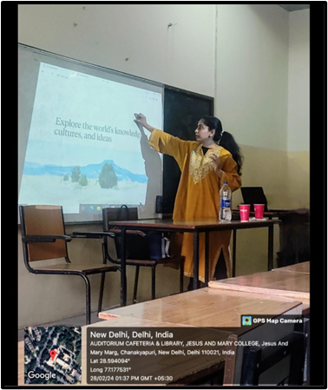

# Chanakya The ECONOMICS CELL Informative session

* Date – 20st March 2024
* Time - 1:00-2:00pm
* Venue – Seminar room L building
* Total Attendees: 25+

Chanakya, The Economics Cell at Jesus and Mary College, hosted a session titled "Unconventional Opportunities for Graduates in Economics" in the seminar room (L building). With over 25 attendees, the event featured insightful discussions on leveraging economics in diverse career paths, emphasizing skills like public relations and market analysis. Attendees were encouraged to adopt a proactive approach to personal growth and were inspired by practical strategies for professional development.

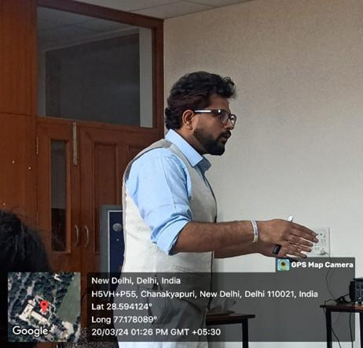

# Speaker Session

* Date: 2 March 2024
* Time : 11:30-12:30
* Venue: ZOOM Meeting
* Attendees:61 students

The Department of Economics at Jesus and Mary College, in collaboration with Meghnad Desai Academy of Economics, organized a speaker session on the "Application of Data Science in Economics,". The session aimed to enlighten students about the significance of Artificial Intelligence in today’s industry landscape, offering them a competitive edge in academic and career pursuits. The guest speaker, **Prof. Amlesh Kanekar,** Director of Academics at Meghnad Desai Academy of Economics and a seasoned professional with over 30 years in IT, Banking, and Finance, led an interactive discussion.



Prof. Kanekar discussed the significance of AI tools like ChatGPT and applications in fintech, including banking, trading algorithms, and insurance tech. The event concluded with an interactive Q&A, providing valuable insights for students into the intersection of data science and economics

# Engaging with Alumni

* + Date: 13th march 2024
  + Time: 12:45 am-2 :00 pm
  + Venue: 308
  + Attendees : 50

The Department of Economics at Jesus and Mary College organized an Alumna Connect featuring **Ms. Shreya Bajaj,** focusing on her journey into the Indian Economic Services.The session began with Ms. Bajaj sharing her undergraduate experiences at JMC and the pivotal role they played in her development

.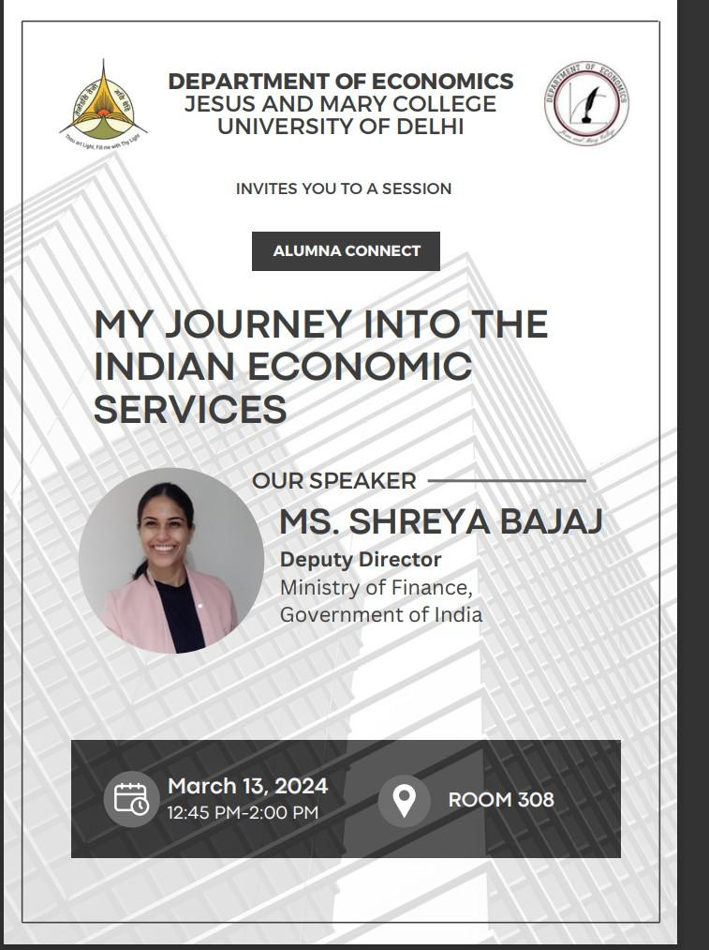

She also detailed her preparation for UPSC exams during her postgraduate studies, offering firsthand insights into the challenges and rewards of pursuing this career path. The event concluded with a Q&A session where Ms. Bajaj addressed various student queries, emphasizing the importance of dedication in achieving professional goals.

Overall, the Alumna Connect session was highly successful, providing students with valuable perspectives on careers in economics and the pathways to success in the Indian Economic Services.